

**Product Dissection for Swiggy Food Delivery App**

### **Company Overview:**

Swiggy, founded in 2014 in Bangalore, India, by Sriharsha Majety, Nandan Reddy, and Rahul Jaimini, has rapidly emerged as a prominent player in the food delivery industry. It has revolutionised the way people order food by leveraging technology to offer a seamless and convenient platform for food delivery services.

With its user-friendly mobile app and website, Swiggy provides customers with access to a wide range of restaurants and cuisines, enabling them to order food with just a few taps on their smartphones. The company's extensive network of delivery partners ensures timely and efficient delivery of orders to customers' doorsteps.

Swiggy has garnered a reputation for its quick delivery, reliability, and quality of service. It has expanded its presence to numerous cities across India, catering to the diverse culinary preferences of its users. Additionally, Swiggy has introduced innovative features such as real-time order tracking, customer support, and various payment options, further enhancing the overall user experience.

### **Product Dissection and Real-World Problems Solved by Swiggy:**

* **Convenience in Food Ordering:** Swiggy meets the demand for easy and speedy access to a variety of cuisines from local and popular eateries.
* **Effective Delivery System:** It tackles the issue of time-consuming and sometimes inconvenient tasks of dining out or picking up food, particularly in bustling urban regions.
* **Various Food Choices:** Swiggy grants entry to an extensive array of food selections, accommodating diverse palates and dietary needs.

### **Case Study: Real-World Problems and Swiggy's Innovative Solutions**

**Problem 1: Time Constraints and Limited Access to Food**

**Real-World Challenge:** In the-paced world of today, individuals frequently lack the time or resources to prepare regular meals. Healthy and varied food options can also be scarce, particularly in regions with few eateries or grocery stores.

**Swiggy's Solution:** Swiggy offers a convenient and easily accessible solution by collaborating with an extensive network of restaurants and food sellers. Customers can peruse menus, make orders, and monitor their deliveries in real-time, all through a user-friendly application. This tackles the issue of time constraints and provides entry to a broad array of culinary choices, even in areas with minimal physical options.

**Problem 2: Food Discovery and Decision Fatigue**

**Real-World Challenge:** When confronted with a multitude of dining options, such as various restaurants and cuisines, making a choice can feel overwhelming. Spending time scrolling through numerous menus and reviews may result in feeling mentally drained and struggling to decide.

**Swiggy's Solution:** Swiggy addresses this issue by offering personalised suggestions and handpicked content. By utilizing user data and location information, the application recommends eateries and meals based on individual preferences and dietary requirements. Moreover, Swiggy provides specially curated lists and collections that showcase popular selections, emerging trends, and local favorites. These features aid users in discovering fresh alternatives and swiftly making informed choices.

**Problem 3: Lack of Transparency and Trust in Food Delivery**

**Real-World Challenge:** Worries regarding cleanliness, food safety, and order accuracy can discourage individuals from utilizing food delivery services. A lack of openness in the delivery procedure can also result in annoyance and distrust.

**Swiggy's Solution:** Swiggy tackles these worries through different strategies. Restaurants are selected based on hygiene and food safety certifications. The platform offers live order tracking, enabling users to observe the delivery progress in real-time. Furthermore, Swiggy provides customer support and mechanisms for addressing grievances to ensure transparency and foster trust.

**Conclusion:**

Swiggy's remarkable success stems from its keen understanding and effective resolution of real-world challenges encountered by its users. Through its emphasis on convenience, food exploration, transparency, and service expansion, Swiggy has ingrained itself as a vital component of numerous Indian households. The platform's ongoing innovation and dedication to addressing user needs are poised to cement its status as a premier food delivery and convenience service provider in the Indian market.

## **Top Characteristics of Swiggy:**

1. **Simple-to-Utilize Interface:** A user-friendly application design that simplifies browsing and ordering food effectively.
2. **Extensive Variety of Eateries:** Access to a broad range of restaurants and food types.
3. **Live Monitoring:** Permits clients to track their orders in real-time.
4. **Numerous Payment Choices:** Provides different payment options such as cash on delivery, e-wallets, and online banking.
5. **Evaluations and Comments:** Users have the ability to rate and provide feedback on restaurants and meals, aiding others in making well-informed decisions.

**Impact on the Food Delivery Industry:**

Swiggy's proactive approach to addressing real-world challenges in the food delivery sector has not only revolutionised consumer convenience but has also left a profound impact on the industry by:

**Enhancing Customer Reach for Restaurants:** Through strategic partnerships with Swiggy, restaurants have witnessed a substantial expansion in their customer base, leading to increased visibility and revenue generation.

**Creating Employment Opportunities:** The surge in demand for delivery personnel driven by Swiggy's operations has facilitated job creation across various regions, thereby contributing to economic growth and livelihood opportunities.

**Promoting Food Culture Diversity:** Swiggy's expansive platform has simplified the exploration and enjoyment of diverse cuisines for consumers, fostering a greater appreciation and dissemination of various food cultures within communities.

### **Schema Description:**

Swiggy's schema comprises multiple entities, each representing distinct facets of the platform's functionality, such as Users, Restaurants, Orders, Deliveries, and more. Each entity is characterised by specific attributes that delineate its properties and associations with other entities within the system.

**User Entity:**

Users are essential to the platform, representing individuals who use the service:

* **UserID (Primary Key):** A unique identifier for each user.
* **Username:** The chosen username for the user's account.
* **Email:** The user's email address for account-related communication.
* **Phone_Number:** The user's contact number.
* **Address:** Stored addresses for delivery purposes.
* **Password:** Encrypted password for account security.

**Restaurant Entity:**

Restaurants are key partners, providing the diverse food options available on the platform:

* **RestaurantID (Primary Key):** A unique identifier for each restaurant.
* **Name:** Name of the restaurant.
* **Location:** Physical address of the restaurant.
* **Cuisine_Type:** Types of cuisine offered.
* **Rating:**  Average customer rating of the restaurant.

**Orders Entity:**

Orders encapsulate the details of each transaction made by the users:

* **OrderID (Primary Key):** A unique identifier for each order.
* **UserID (Foreign Key referencing User Entity):** The user who placed the order.
* **RestaurantID (Foreign Key referencing Restaurant Entity):**  The restaurant from which the order is placed.
* **Total_Amount:** Total cost of the order.
* **Order_Status:**  Status of the order (e.g., preparing, en route).
* **Order_Date:** The date and time when the order was placed.

**Delivery Entity:**

Deliveries are crucial for transporting orders from restaurants to users:

* **DeliveryID (Primary Key):** A unique identifier for each delivery.
* **OrderID (Foreign Key referencing Orders Entity):** The order being delivered.
* **Delivery_ExecutiveID:** Identifier for the delivery executive.
* **Estimated_Delivery_Time:** Expected time for the order to be delivered.
* **Delivery_Status:** Current status of the delivery (e.g., picked up, delivered).

**Payment Entity:**

Payments record the financial transactions for each order:

* **PaymentID (Primary Key):** A unique identifier for each payment transaction.
* **OrderID (Foreign Key referencing Orders Entity):** The order for which the payment is made.
* **Amount:** Amount of the transaction.
* **Payment_Method:** Method of payment (e.g., card, wallet, COD).
* **Payment_Status:** Status of the payment (e.g., successful, pending).

**Item Entity (represents items in an order):**

Items represent the individual menu selections included in an order:

* **ItemID (Primary Key):** A unique identifier for each menu item.
* **OrderID (Foreign Key referencing Orders Entity):** The order including this item.
* **Name:** Name of the item.
* **Quantity:** Number of items ordered.
* **Price:** Price of the item.

**Relationships:**

* **Users place Orders:** Each user can place multiple orders, and each order is linked to a single user.
* **Orders contain Items:** Each order can contain multiple items, and each item is part of one order.
* **Restaurants fulfil Orders:** Each order is associated with one restaurant, and a restaurant can have multiple orders.
* **Orders require Delivery:** Each order is linked to a single delivery instance, and each delivery is associated with one order.
* **Orders involve Payments:** Each Order is associated with one Payment, and each Payment corresponds to one Order.

**ER Diagram:**

Let's create an Entity-Relationship (ER) diagram to clearly illustrate the connections and characteristics of the elements in the Swiggy database structure. This ER diagram will act as a visual guide, highlighting the essential parts of Swiggy's data architecture. Utilising this diagram will help us understand the complex relationships and interactions that shape the functioning of the platform.

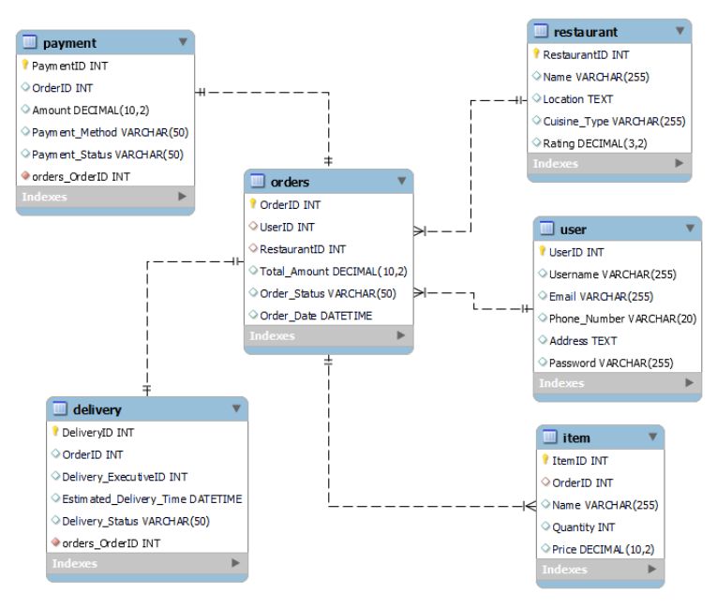

**Fig: ER Diagram**

### 

### **Conclusion**

In this study, we have analysed Swiggy's operational framework and its impact on the food delivery ecosystem. Swiggy has transformed the landscape of food ordering and delivery by addressing real-world challenges through technological innovation and user-centric solutions. The platform integrates entities such as users, restaurants, orders, deliveries, payments, and menu items, creating a robust and efficient system. This comprehensive structure not only facilitates seamless transactions but also caters to a diverse range of consumer needs and preferences. By analysing Swiggy's model, we gain valuable insights into how it successfully navigates the complexities of the food delivery sector, enhancing convenience for customers while providing vital support to restaurant partners. Swiggy's strategic approach and adaptive technology have propelled its growth, cementing its position as a leading player in the ever-evolving domain of online food services.

Project by - Rohit Kumar

Email - [rapidformation1210@gmail.com](mailto:rapidformation1210@gmail.com)

Github - [Mephistoe/Swiggy-Product-Dissection (github.com)](https://github.com/Mephistoe/Swiggy-Product-Dissection)